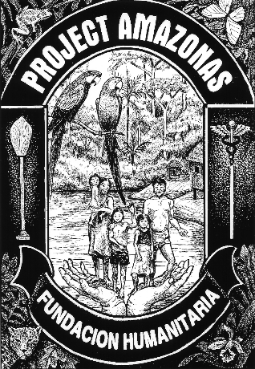
Dedicated to the People and Environment of the Amazon: Working to Ensure the Future through Conservation, Research, Education, Medical Care and Sustainable Development.

Dedicada a la Gente y Medioambiente de la Amazonia: Trabajando para asegurar su Futuro por Medio de Conservación, Investigación, Educación, Asistencia Medica y Desarrollo Sostenible

26 February 2012

To: Whom it May Concern

Re: Letter of Support for Claire Sharpin – Amazon medical service trip participant

Dear Reader;

I am providing this letter in support of fund-raising efforts by Ms. Claire Sharpin who will be participating in a medical service expedition in the Peruvian Amazon from 29 July to 9 August 2012 to the Nanay and Pintoyacu Rivers. Such service expeditions depend heavily on the efforts of volunteer medical students who complement the work of the medical doctors and dentists who anchor the expeditions and who serve as the on-site experts.

The rivers in question are in dire need of medical care and of health education services. Easily preventable medical conditions and diseases are common, and lack of clean water and proper sanitation exacerbates the chronic health problems of the residents. The existing government clinics have dedicated staff, but are poorly equipped and incapable of meeting the needs. Many small communities are also many hours to several days travel by small boat from the nearest government clinic, so service expeditions like the one on which Ms. Sharpin will participate serve the important role of taking health care and health education services directly to those communities.

Project Amazonas has been conducting medical care activities in the Peruvian Amazon since 1998, and has a formal agreement signed with the Peruvian Ministry of Health (Iquitos, Loreto, Peru) to provide such services. The organization is recognized as an official non-governmental, non-profit organization at the national level in Peru, and has also been incorporated as a 501(c)3 non-profit organization in the State of Florida since 1994 (EIN 65-1515019). As such, any donations of funds or materials to Project Amazonas in support of Ms. Rodriguez’ project are tax-deductible to the extent allowed by US tax laws. Project Amazonas will be happy to provide a receipt for tax and general accounting purposes. We regret that we are unable to provide tax benefits to donors from other countries, but assure you that your support of such health care efforts is much appreciate, both by us, and by the beneficiary communities.

Thank you for your consideration and support of efforts to improve health and well-being in remote and underserved areas of the Amazon. Please contact us at any time if you have any questions.

Sincerely,
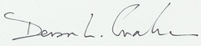
Devon L. Graham, Ph.D.
President/Scientific Director – Project Amazonas, Inc., Ft. Lauderdale, FL
devon@projectamazonas.org

